Stage 4 ★
Mixed Selection 2

- Penny farthing
Boris Biker entered the Tour de Transylvania with an unusual bicycle whose front wheel is larger than the back. The radius of the large wheel is 40cm, and the radius of the small wheel is 30cm.
On the first stage of the race the smaller wheel made 120,000 revolutions. How many revolutions did the larger wheel make?

- Tadpoles
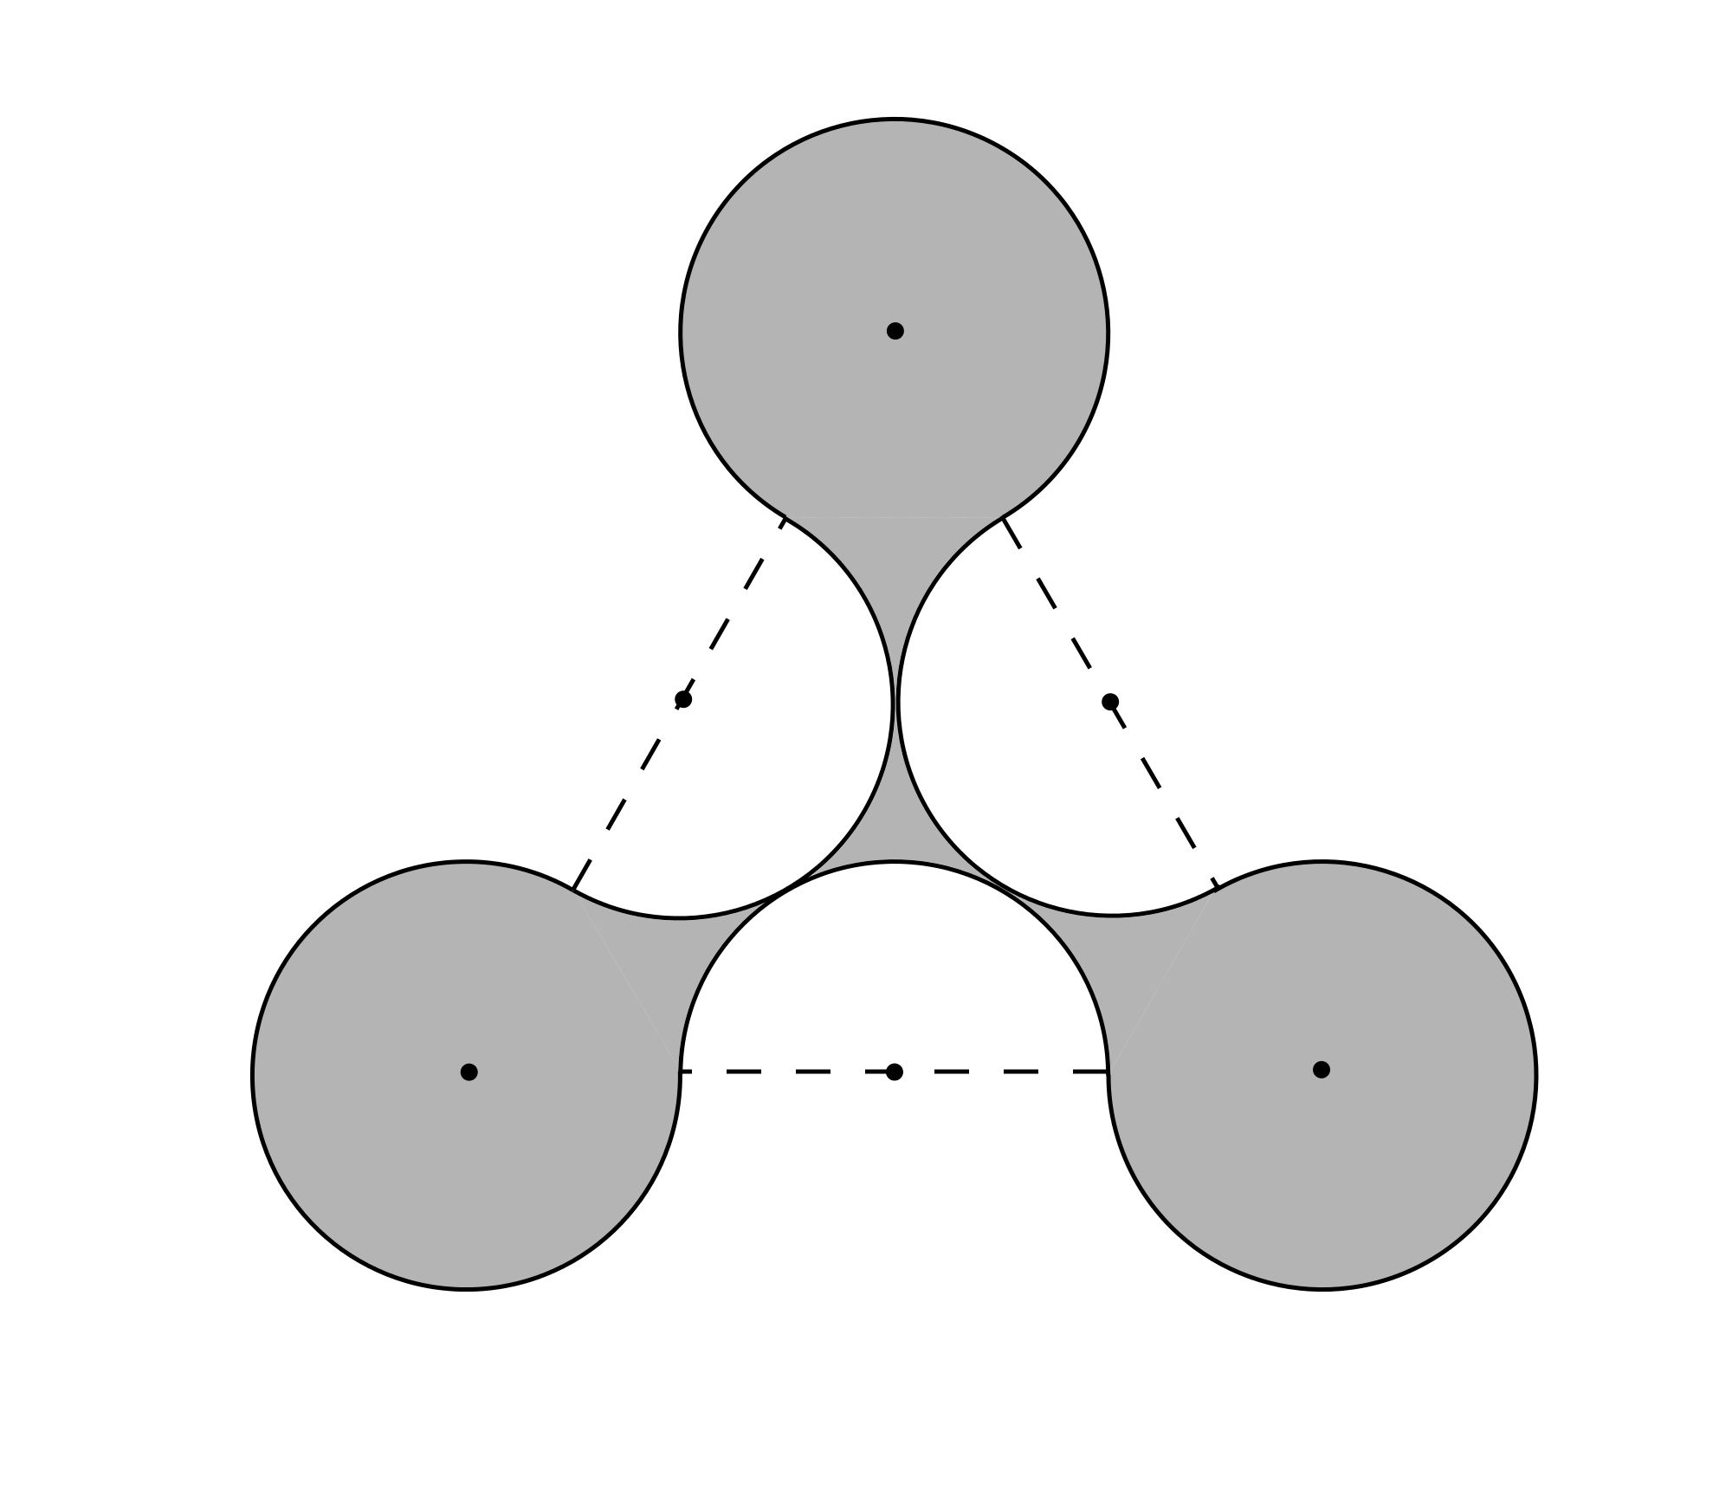
The diagram shows a shaded shape bounded by circular arcs with the same radius. The centres of three arcs are the vertices of an equilateral triangle; the other three centres are the midpoints of the sides of the triangle. The sides of the triangle have length 2.
What is the difference between the area of the shaded shape and the area of the triangle?

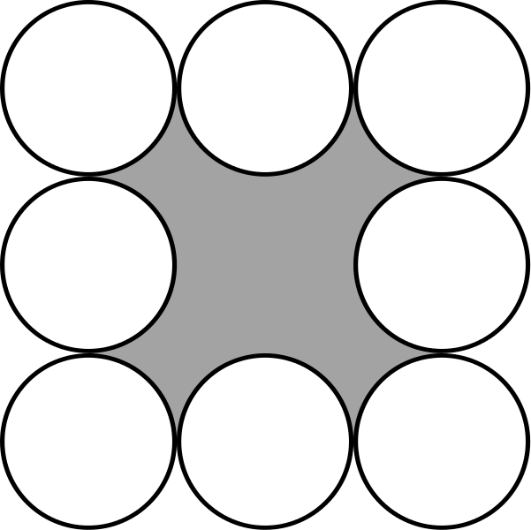
- Square Flower
The shaded region is bounded by eight equal circles with centres at the corners and midpoints of the sides of a square.
The perimeter of the square is 8cm. What is the perimeter of the shaded region?

- Crazy shading
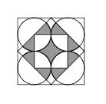
The diagram shows four circles each of which touches the largest square and two adjacent circles. A second square has its vertices at the midpoints of the sides of the largest square and the central square has its vertices at the centres of the circles.

What is the ratio of the total shaded area to the area of the outer square?

